XRAY FUNDAMENTALS & HANDS-ON PRACTICE

Introduction to Xray

What is Xray?
Xray is a test management tool integrated with Jira. It helps software testing teams create test cases, execute tests, track results, and manage defects.

Why Xray is Used
Xray helps to:
    - Manage manual and automated test cases.
    - Track testing progress.
    - Connect requirements with test cases.
    - Identify and report defects.
    - Generate test reports.

Xray in Agile Projects
Xray supports Agile testing by connecting requirements, test cases, and test executions. It helps developers and testers work together and maintain software quality.

Xray Core Concepts

Xray Test
Used to create individual test cases with test steps, test data, and expected results.

Precondition
Defines the conditions that must be satisfied before executing a test case.

Test Set
Groups related test cases into one collection.

Test Plan
Defines the testing scope for a particular release or testing campaign.

Test Execution
Records the actual execution of test cases and their results.

Sub Test Execution
Organizes testing activities under a parent test execution.
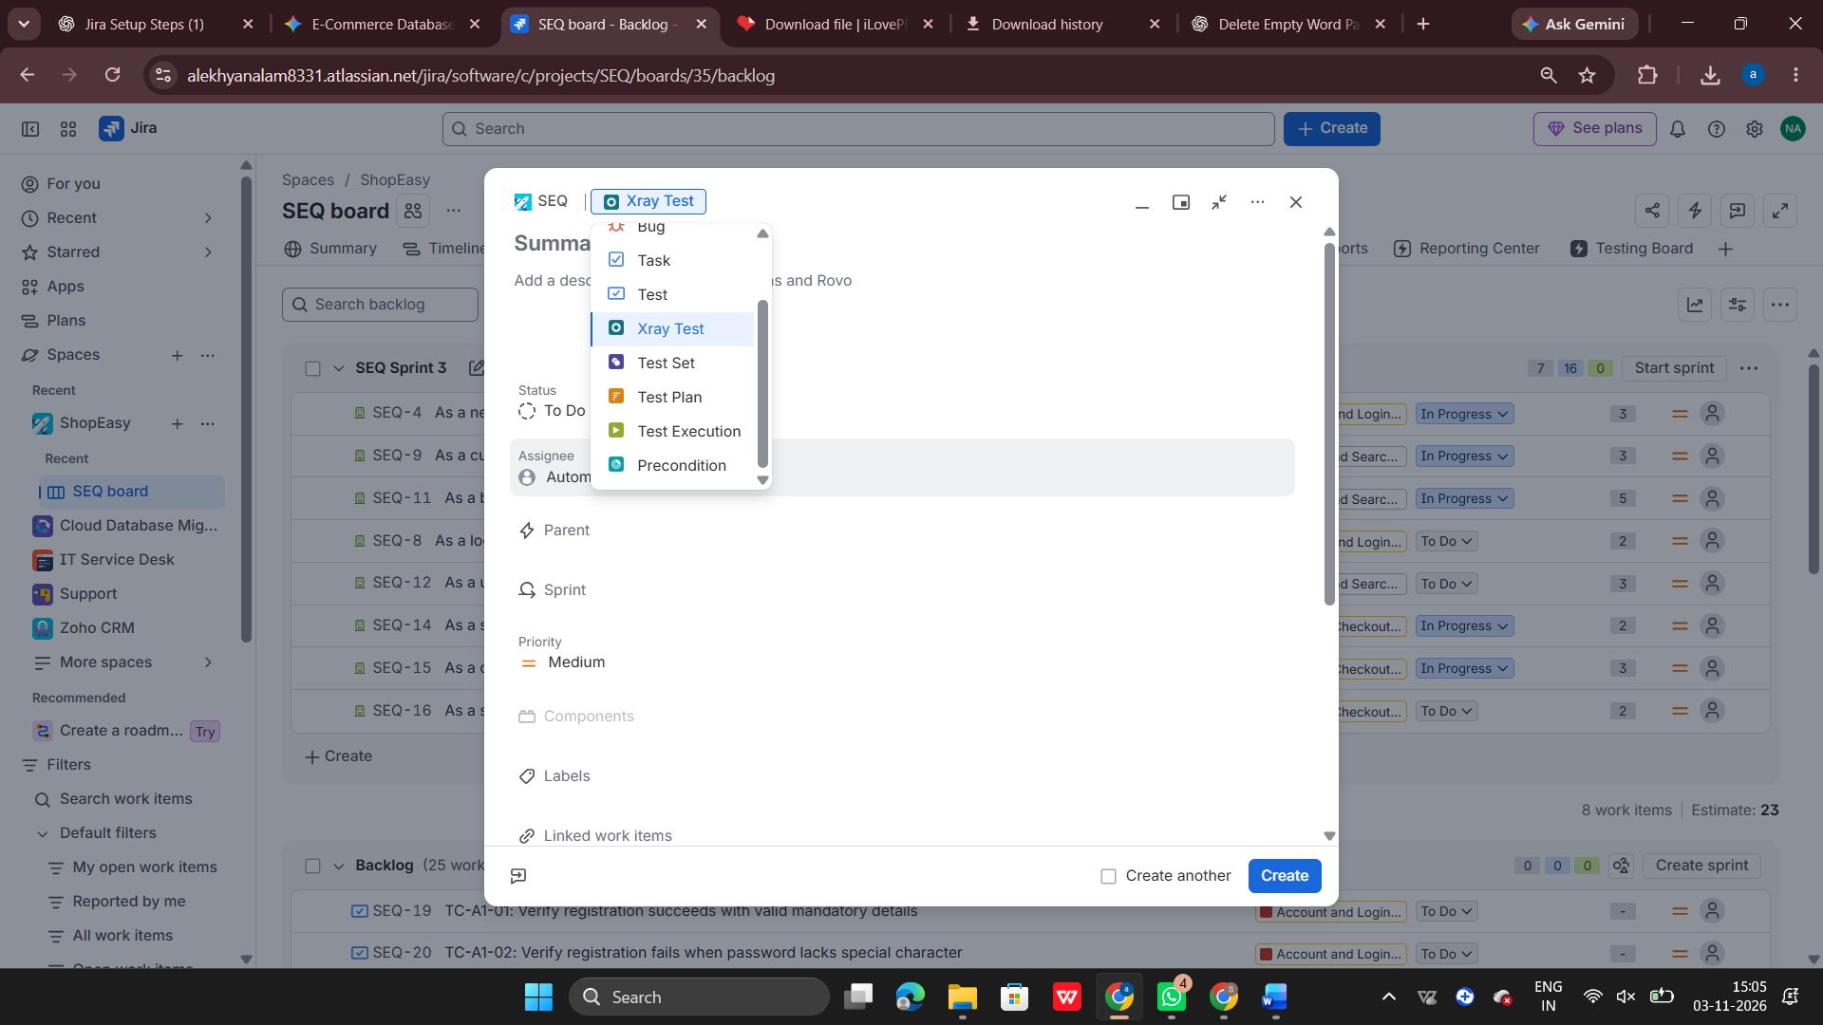

Understanding Requirements and Test Scenarios
  - Business Requirement
Worked on a Student Management System project with a Student Login module. Requirement:
As a student, I want to log in using my registered email and password so that I can access my personal dashboard.

Acceptance Criteria
    - Login should succeed with valid credentials.
    - Invalid email and password should not be accepted.
    - Email and password fields should be mandatory.
    - Password should be displayed in masked format.
    - Successful login should redirect to the dashboard.

Test Scenarios
Identified different scenarios for testing the login functionality, including:
    - Valid login.
    - Invalid email.
    - Incorrect password.
    - Empty email.
    - Empty password.
    - Both fields empty.
    - Password masking.
    - Dashboard redirection.
    - Invalid email format.
    - Inactive student account.

Creating Test Cases
Created manual test cases for the Student Login module. Each test case contains:

- Summary
- Description
- Test Type
- Preconditions
- Action
- Test Data
- Expected Result
Created test cases to verify both positive and negative login scenarios.

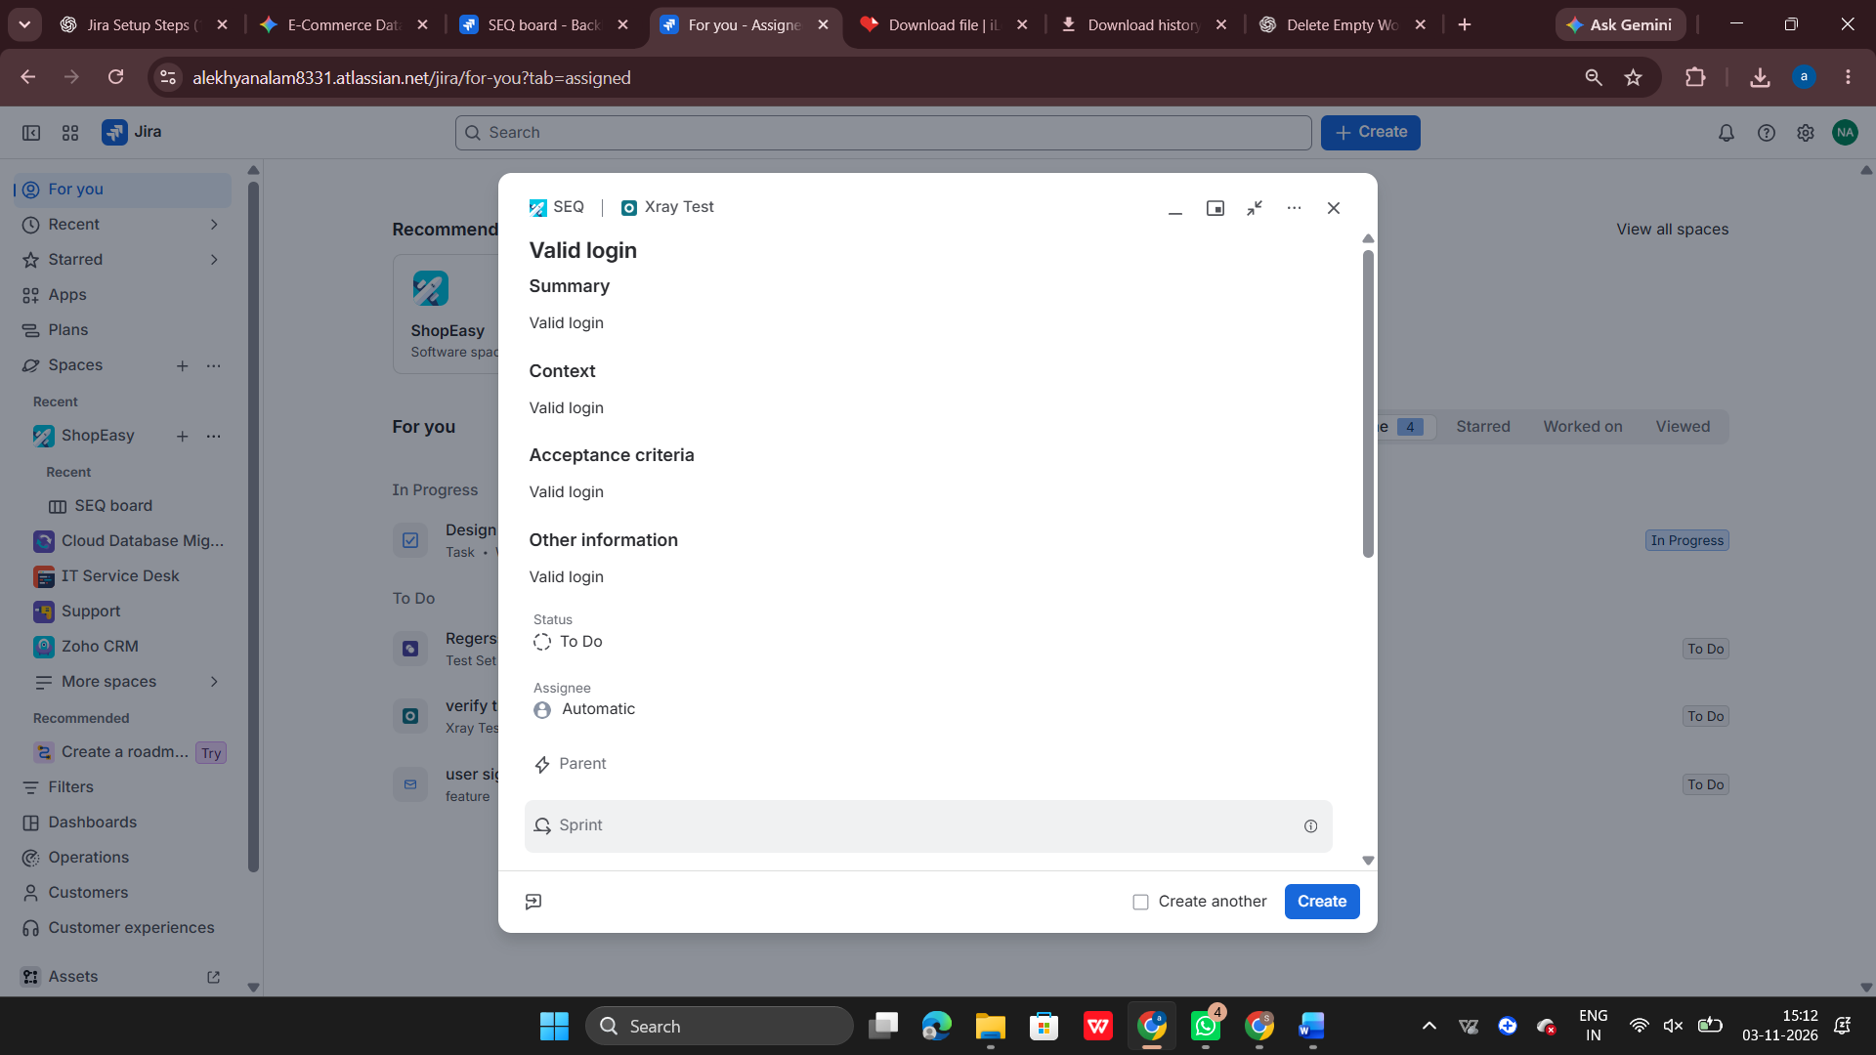

5.Requirement Traceability
Learned how to link Xray test cases with Jira Stories.
This helps the testing team understand which requirements are covered by test cases and identify requirements that still need testing.

Test Set and Test Plan

Test Set
Created a Student Login Test Suite to group related login test cases.

Test Plan
Created a Test Plan for Student Management System – Release 1.0. It defines the testing scope, target environment, and release details.

Test Execution
Created a Test Execution for the Student Login module in the QA environment. Added test cases to the execution and recorded their execution results.

Test Results
    - PASS – The actual result matches the expected result.
    - FAIL – The actual result does not match the expected result.
    - PENDING – The test has not yet been executed.
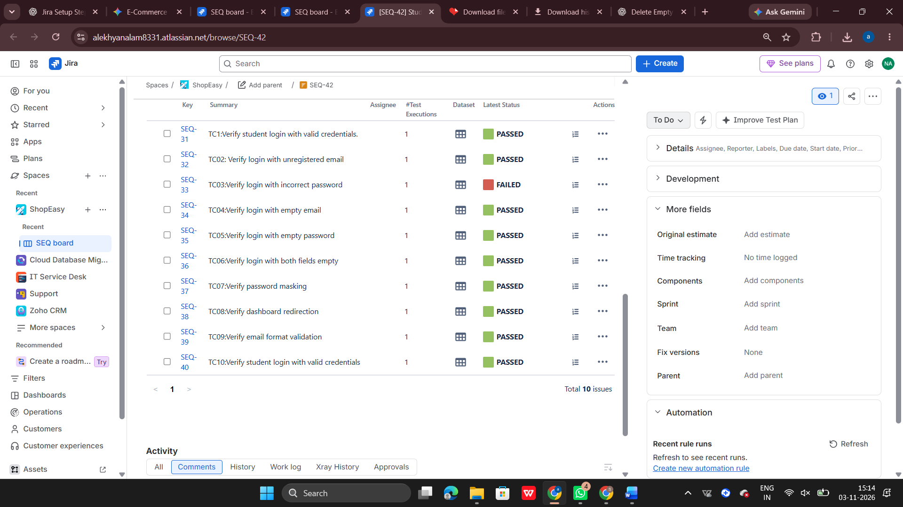

Bug Reporting and Defect Management
Learned how to identify and report defects when a test case fails. Created a sample Bug for the empty email validation issue.
The bug report includes:
- Bug Summary
- Steps to Reproduce
- Expected Result
- Actual Result
- Priority
- Testing Environment
Also learned how to link the Bug with the failed test case.

Retesting
Learned how to retest a failed test case after the developer fixes the defect. Created a second Test Execution to verify the fix and maintain execution history.

Xray Reports
Explored the importance of Xray reports for tracking testing activities. Important reports include:
- Test Execution Report
- Test Plan Report
- Requirement Coverage Report
- Traceability Report
These reports help managers understand testing progress, passed and failed tests, and defect status.
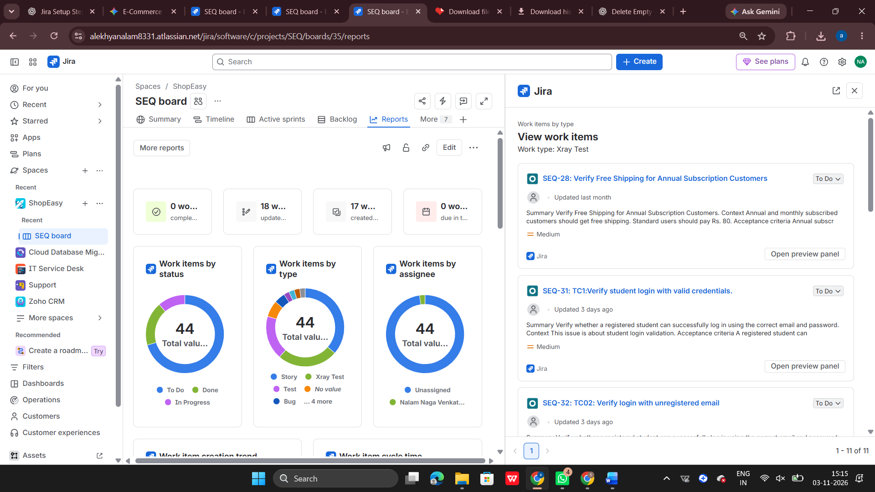

Hands-On Practical Work
Completed practical activities using Jira and Xray:
- Created a Student Login Story.
- Created a Precondition.
- Created manual test cases.
- Linked test cases with the requirement.
- Created a Test Set.
- Created a Test Plan.
- Created a Test Execution.
- Executed test cases and recorded results.
- Created and linked a Bug.
- Performed retesting.
- Explored Xray reports.
- Learned the complete Xray testing workflow.
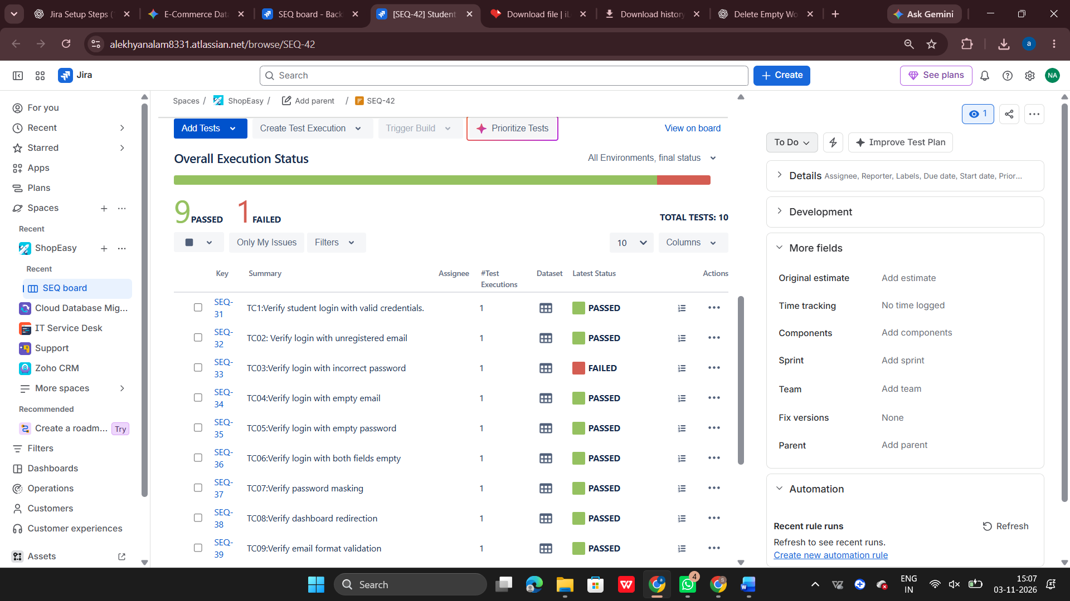

Conclusion
Through this practical training, I learned the fundamentals of Xray and its integration with Jira. I also gained practical knowledge of creating test cases, organizing tests, executing test cases, reporting defects, retesting, and generating test reports

